IT Directorate (Senate of Pakistan)

IPR Management SysteM
Outgoing Visit Management / DA Calculation

Login

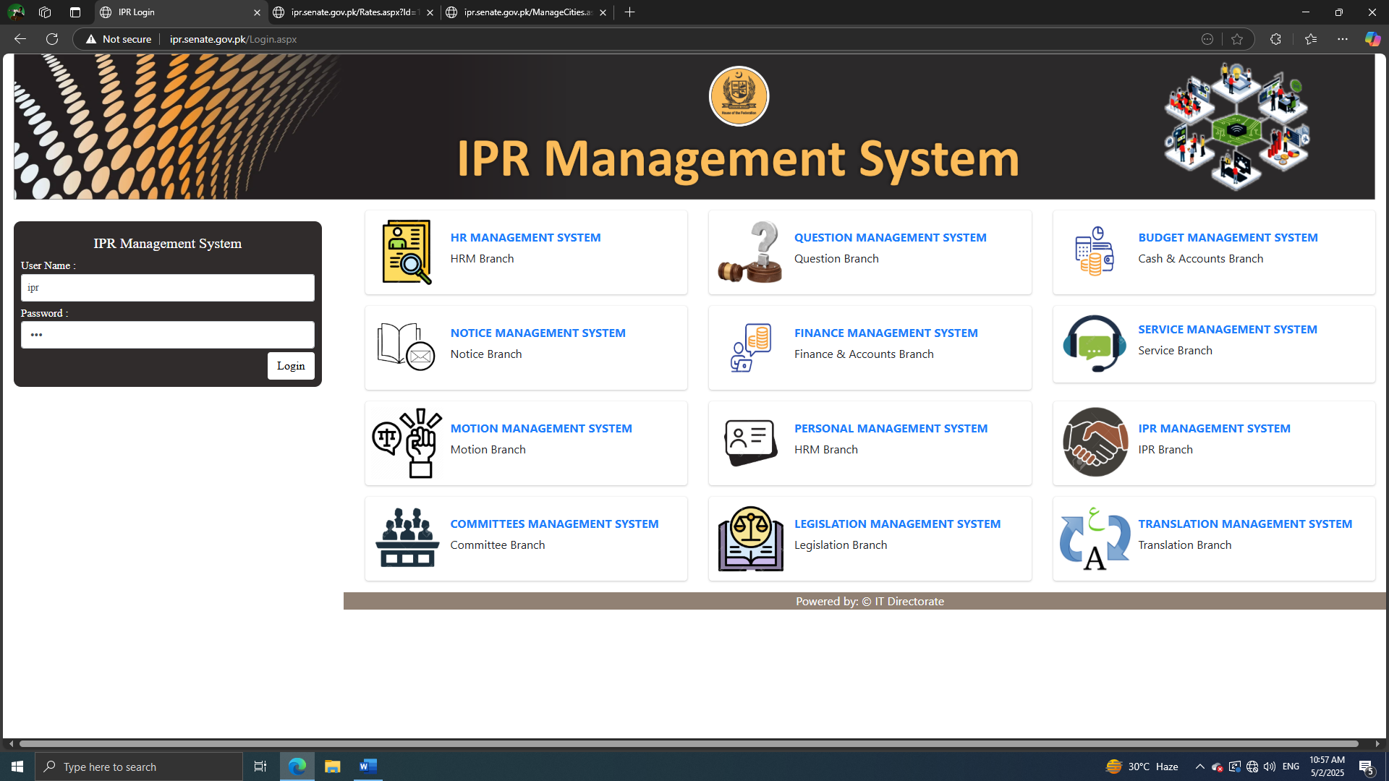
Manage Countries

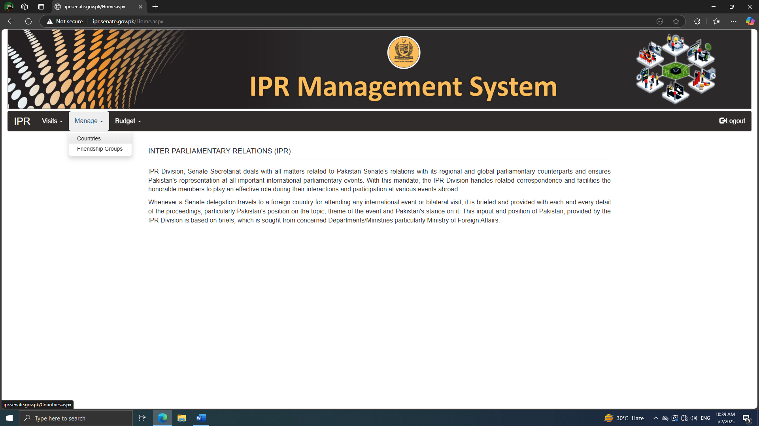
Manage Cities, Locations and Rates

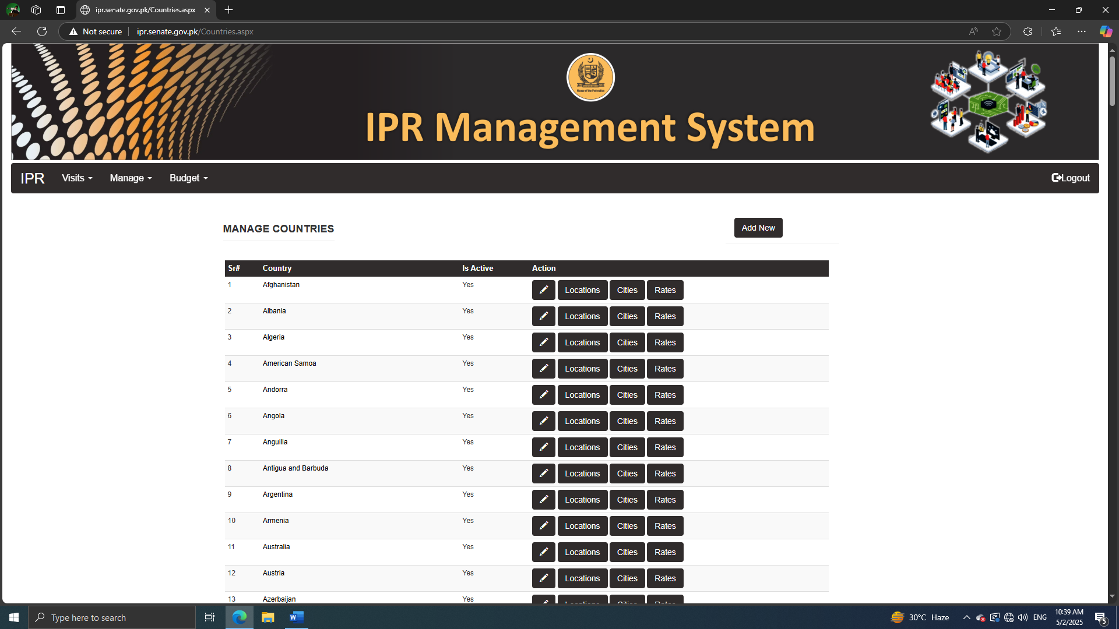
Add, Edit , Delete Locations in Country

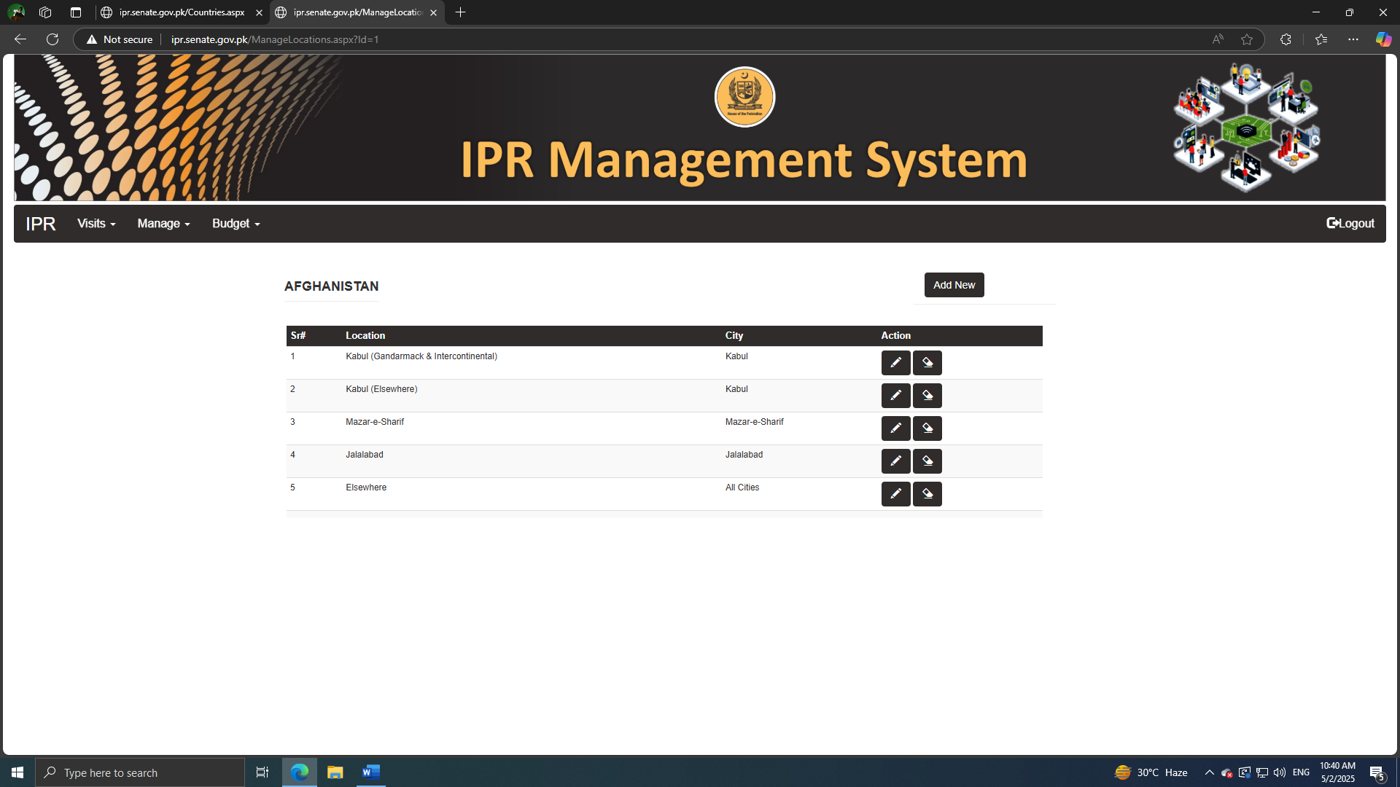
Add, Edit Delete Cities of Country

Manage Category wise Rates of Locations

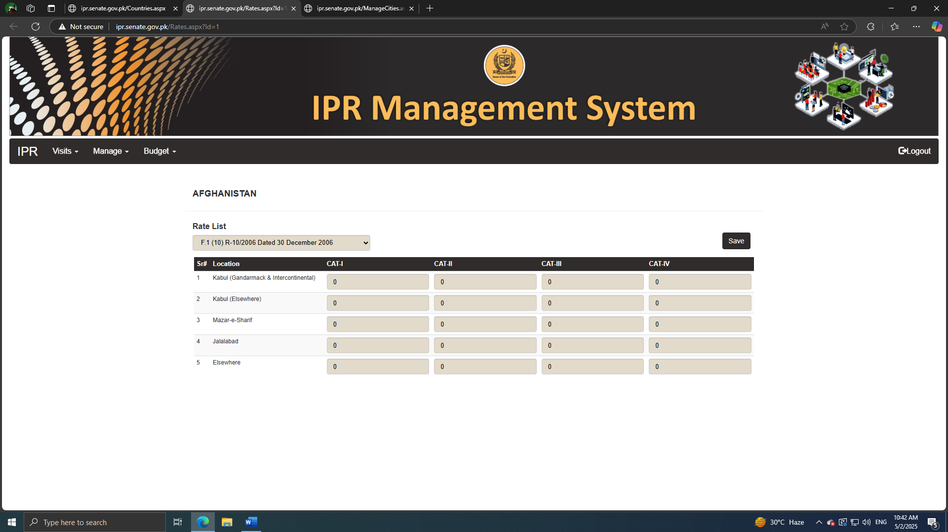
Manage Outgoing Visits

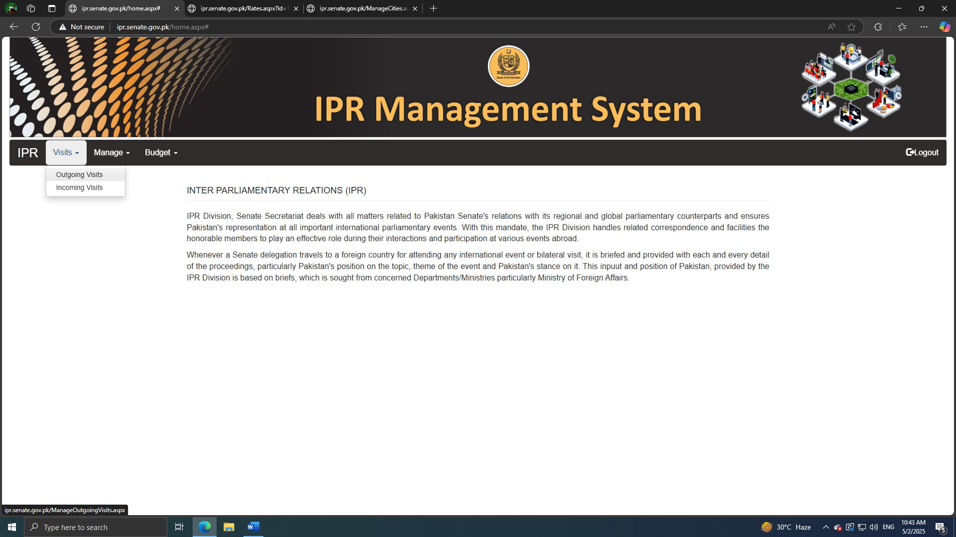
Add, Edit and Manage Outgoing Visits

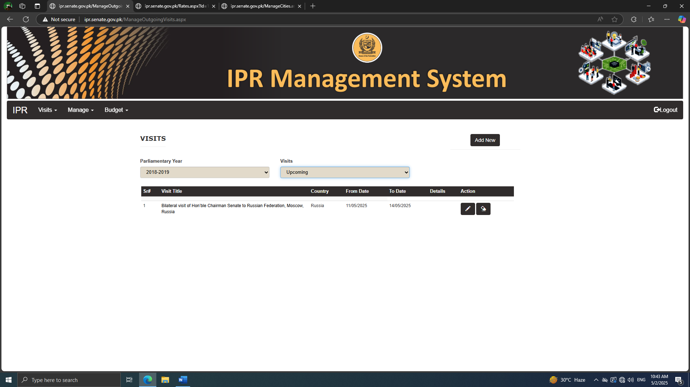
Click on Visit Title to Manage Specific Visit

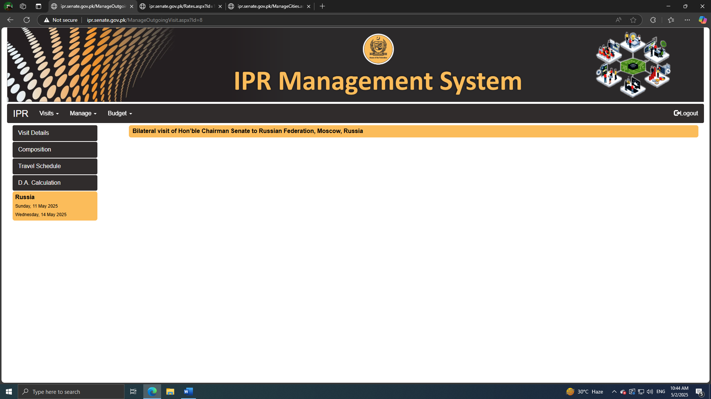
Manage Composition of Visit

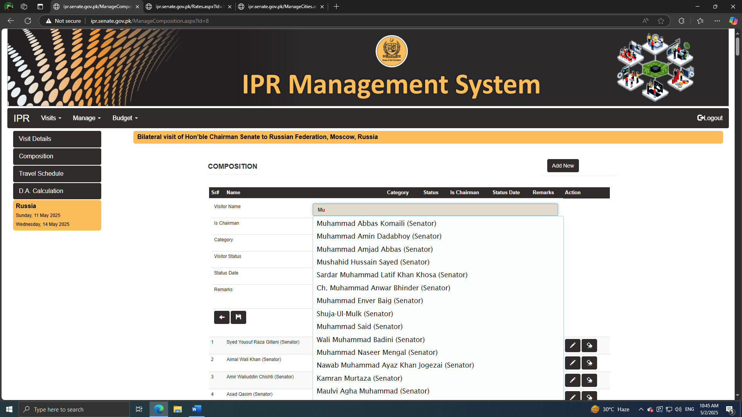
Enter Visit Locations and arrangement details and Select Members

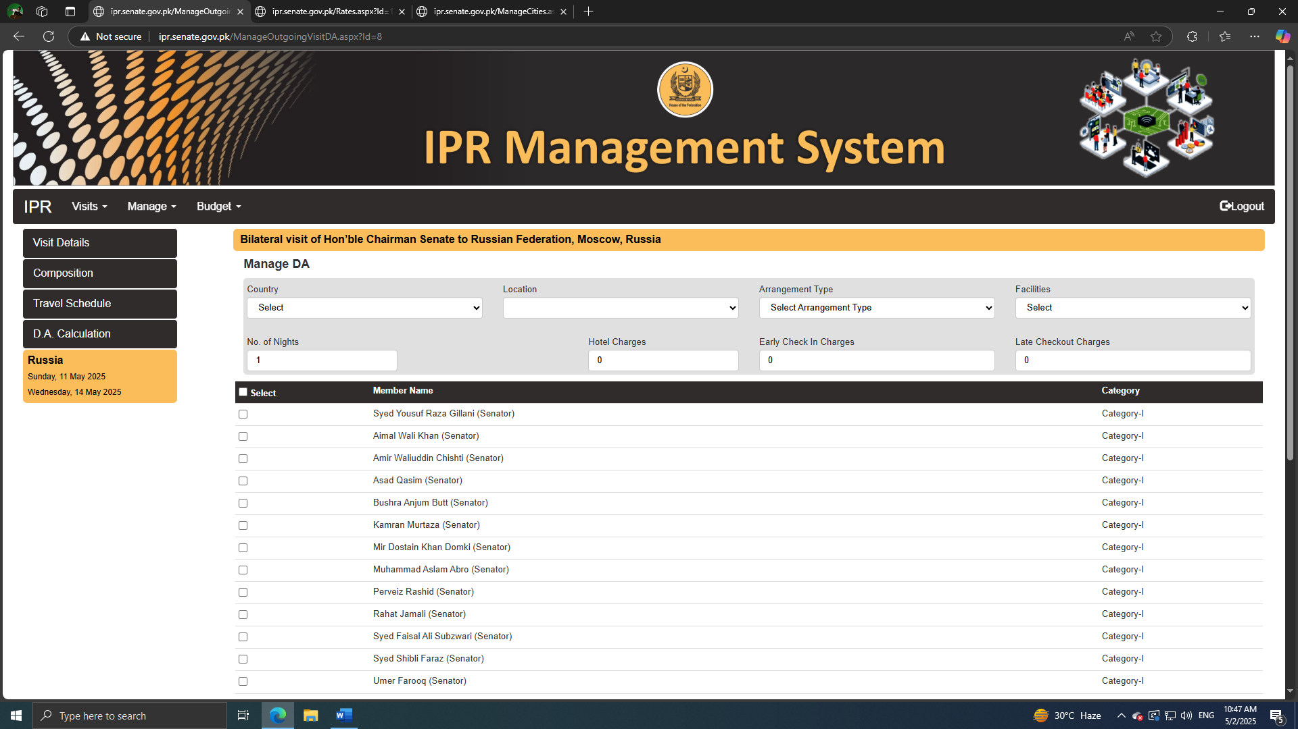
Entries will be added below the Members list

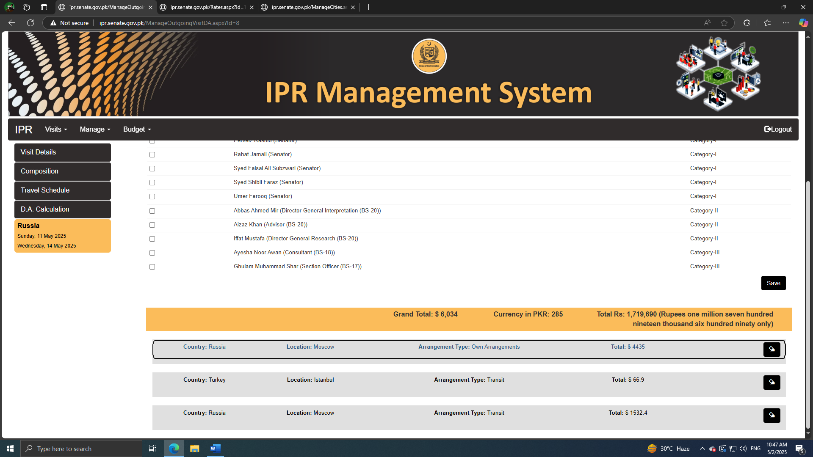
Click on Entry to view details

